Name Catherine Pollock Date 10/19/14_________________
Laboratory 9: Cover Sheet

Section 1001
Place a check mark in the Assigned column next to the exercises your instructor has assigned to you. Attach this cover sheet to the front of the packet of materials you submit following the laboratory.

Activities | Assigned: Check or list exercise numbers | Completed
Implementation Testing | ✓
Programming Exercise 1 | ✓
Programming Exercise 2 | ✓
Programming Exercise 3
Analysis Exercise 1 | ✓
Analysis Exercise 2 | ✓
 | Total

Name Catherine Pollock Date 10/19/14_________________
Laboratory 9: Implementation Testing

Section 1001

Check with your instructor whether you are to complete this exercise prior to your lab period or during lab.

Test Plan 9-1 (Binary Search Tree ADT operations)
Test case |  | Commands | Expected result | Checked
Empty tree  1  2  3  Single branch  1  2  3  4  5  Only right branch  1  2  3  4  Single item  1  2  3  Many branches  1  2  3  4  5  6  7  8  9  10 |  | -  K  C  E  +9+3  ?3  ?4  -0  -9  K  +0+1+2+3  K  ?0  C  K  +8  ?8  ?18  -8  +51+73+99+32+35+21+7+1+97+42  K  -7  ?35  -51  +101  K  -51  ?1  C  K | Keys:  Clear the tree  Tree is empty  Retrieved : getKey = 3  Not found  Not found  Removed data item  Keys: 3  Keys: 0 1 2 3  Retrieved : getKey = 0  Clear the tree  Keys:  Retrieved : getKey = 8  Not found  Removed data item  Keys: 1 7 21 32 35 42 51 73 97 99  Removed data item  Retrieved : getKey = 35  Removed data item  Insert : key = 101  Keys: 1 7 21 32 35 42 73 97 99 101  Not found  Retrieved : getKey = 1  Clear the tree  Keys: | Yes  Yes  Yes  Yes  Yes  Yes  Yes  Yes  Yes  Yes  Yes  Yes  Yes  Yes  Yes  Yes  Yes  Yes  Yes  Yes  Yes  Yes  Yes  Yes  Yes

Name Catherine Pollock Date 10/19/14_________________
Laboratory 9: Programming Exercise 1

Section 1001

Test Plan 9-2 (accounts database indexing program)
Test case |  | Expected result | Checked
 | 6274  2843  4892  8337  1892  9523  3165  3924  6023  5290  8529  1144  9999 | 0 : 6274 James Johnson 415.56  1 : 2843 Marcus Wilson 9217.23  2 : 4892 Maureen Albright 51462.56  3 : 8337 Debra Douglas 27.26  4 : 1892 Bruce Gold 719.32  5 : 9523 John Carlson 1496.24  6 : 3165 Mary Smith 918.26  7 : 3924 Simon Becker 386.85  8 : 6023 John Edgar 9.65  9 : 5290 George Truman 16110.68  10 : 8529 Ellen Fairchild 86.77  11 : 1144 Donald Williams 4114.26  No record with that account ID | Yes  Yes  Yes  Yes  Yes  Yes  Yes  Yes  Yes  Yes  Yes  Yes  Yes

Name Catherine Pollock Date 10/19/14_________________
Laboratory 9: Programming Exercise 2

Section 1001

Test Plan 9-3 (getCount operation)
Test case |  | Commands | Expected result | Checked
Many branches  1  2  3  Empty tree  1  One branch  1  2  3 |  | +65+23+43+87+9+2+67  G  -65G  -43G  -  G  +1+2+3+4  G  +5G  -1G | 7  6  5  0  4  5  4 | Yes  Yes  Yes  Yes  Yes  Yes  Yes

Test Plan 9-4 (getHeight operation)
Test case |  | Commands | Expected result | Checked
Many branches  1  2  3  Empty tree  1  One branch  1  2  3 |  | +65+23+43+87+9+2+67  H  -65  -43  -  H  +1+2+3+4  H  +5H  -1H | 4  4  3  0  4  5  4 | Yes  Yes  Yes  Yes  Yes  Yes  Yes

Name Catherine Pollock Date 10/19/14_________________
Laboratory 9: Programming Exercise 3

Section 1001

Test Plan 9-5 (writeLessThan operation)
Test case |  | Commands | Expected result | Checked

Name Catherine Pollock Date 10/19/14_________________
Laboratory 9: Analysis Exercise 1

Section 1001

What are the heights of the shortest and tallest binary search trees that can be constructed from a set of N distinct keys? Give examples that illustrate your answer.

The maximum height for a tree of N keys is N. This is the case if each key has only one child, either right or left.
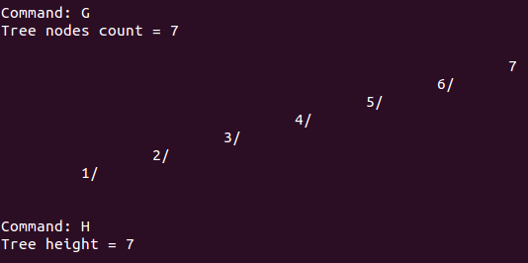
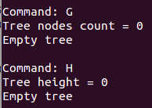
For example:
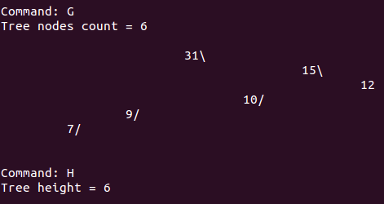
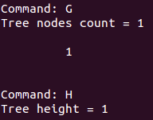

The minimum height for a tree of N keys is log₂(N+1) (rounded up if decimal remainder). This means that each level of the tree (starting at root) must have two children before the next level can have children.
For example:
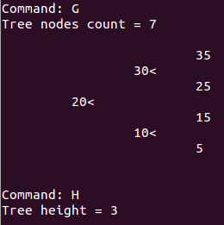
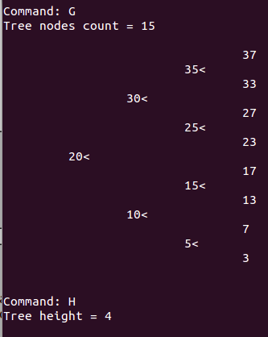
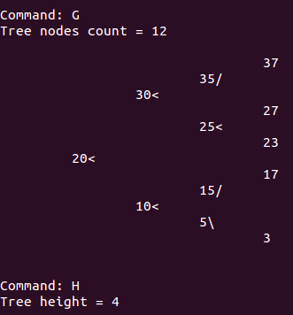
log₂(7+1)=3=3 log₂(15+1)=4=4

log₂(12+1)=3.70=4

Name Catherine Pollock Date 10/19/14_________________
Laboratory 9: Analysis Exercise 2

Section 1001

Given the shortest possible binary search tree containing N distinct keys, develop worst-case, order-of-magnitude estimates of the execution time of the following Binary Search Tree ADT operations. Briefly explain your reasoning behind each of your estimates.

retrieve O( N )
Explanation:
In the worst case scenario, the retrieveHelper function would search all the way from the root node to the node furthest from root, which would make the height equal to the number of nodes ( as explained in previous page ). In the worst case, the helper function would have to compare the value of each node, since each node only has one child ( kind of like a linked list ). Therefore, execution time is estimated for retrieve by O( N ).

insert O( N )
Explanation:
In the worst case scenario, insertHelper would have to try to insert starting from the root, all the way until the node furthest from root, in a tree where each node only has one child ( like a linked list ). This would make the height equal to N, like how described above. The helper function would have to go to each child of each node, making it take N tries to insert. Therefore, execution time is estimated for insertion by O( N ).

remove O( N )
Explanation:
Similar to the previous answers, the worst case scenario would feature a tree where each node has only one child, making it similar to a linked list with height of N. The removeHelper would have to check each node from root until the node furthest from root for removal in the worst case scenario, making the execution time for remove O( N ).

writeKeys O( N )
Explanation:
Similar to the previous answers, the worst case scenario would feature a tree where each node has only one child, making it similar to a linked list with height of N. The writeKeysHelper would have to print each node from root until the node furthest from root for removal in the worst case scenario, making the execution time for writeKeys O( N ).

